**Key Design Guidelines and Principles for Graphical User Interfaces**

These are the key points on design guidelines and principles which I have gathered from various sources from around the web.

**Source 1**: www.msdn.microsoft.com/en-us/library/cc872774.aspx

**Author:** Microsoft

**Published:** N/A

**Key points**:

* Controls should ***move and react the way real-world objects move and react***, such as by having momentum and friction.
* Controls should ***allow users to easily correct mistakes***.
* Controls should ***have feedback that is clearly visible even when the finger is over the control***, such a ripple effect
* The user interface should ***have appropriate default values*** to prevent loss of data from accidental user inputs.
* Whenever practical, ***use larger command buttons*** for important or frequently used commands.
* ***Make the target size larger than the visible UI element***. This would reinforce the accuracy of the system.

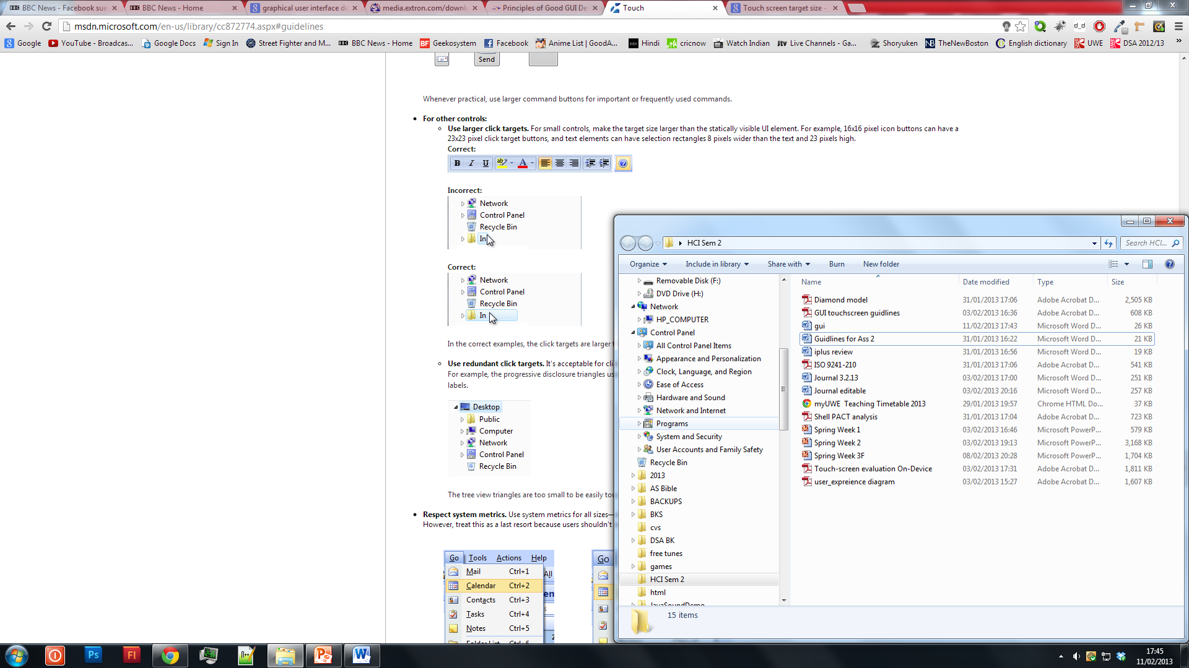

* ***Avoid long distance hand movements***, especially for common tasks and for drags.
* ***Touch keyboards should provide auto-complete*** suggestions when appropriate.
* Ideally a system should feature ***a simple way to undo commands***.
* Provide good feedback on finer down, but don’t take action until finger up.
* Have clear physical separation between frequently used commands and destructive commands. Destructive commands are those which affect the system overall.

**Source 2:** http://media.extron.com/download/files/userman/68-1930-01_101102_designJPG.PDF

**Author:** Extron Electronics

**Published:**  October 2010.

**Key points:**

* Break every part of the interface into chunks, where each chunk has no more than nine parts.
* Touch panel user interfaces must be designed using consistent, logical, and predictable layouts.
* Static areas of a user interface have pre-assigned conditions that do not change during the navigation of the interface or the execution of an action.
* Dynamic areas should be reserved for content that varies based on the mode of the control or the conditions of the selected operation.
* The user should never have to press more than 3 buttons to perform a desired function.
* A well designed interface allows the user to recognize the context of available controls at a glance.
* User interface navigation should always start with clear entry points.
* The screen should have a clean appearance, with each section distinctly separated and controls clearly labelled.
* An icon near text reinforces the functionality of a button.
* Contextual icons help to locate the relevant button more quickly, especially when using a familiar image.
* A palette of harmonious colours should be selected before beginning any GUI design.
* Never use more than six colours on a project.
* Always maintain good contrast between elements.
* Monochrome testing in greyscale is a good way to validate the readability of a user interface design by those who are colour blind or colour deficient.
* Buttons should visually change when pressed, providing accurate feedback of its state.
* Studies have shown that the ideal button size for touchscreens is 0.75 inches (approximately 1.9 cm) square.

**Source 3:**  www.serco.com/Images/Touchscreen%20Design%20Guidelines%20(Apr%2008)_tcm3-32585.pdf

**Author**: Serco

**Published:** April 2008

**Key points:**

* Large good quality screens are essential to provide space for key elements.
* Delays will frustrate and confuse users, encouraging repeated selection of target elements.
* Optimising responsiveness will dissuade users from pounding the keys and/or using their finger, nail or pen, like a stylus.
* To minimise keying errors as much as possible, ensure that sensitivity and screen alignment (calibration) are optimised.
* Maximise sensitivity levels, uniformly, across all areas of the screen.
* Consider the option of a universal stylus to minimise concerns associated with large fingers.
* Consider options to support a more tactile user experience e.g. vibrational sensations in response to user selections.
* If users have problem with the most basic functionality they will feel negative about the product.
* Allow clear and direct navigation to return Home and the Main Menu.
* Ensure consistency throughout the interface, as this reassures users and allows ease of navigation.
* Provide a search option in addition to the option to scroll through a list.
* Provide a Help system that is easy to find and use.
* Make use of familiar icons so users can associate with them.
* Ensure visibility of icons if using abstract designs or faded out/graduated target areas.
* Consider supplementing the icons with labelling or other textual cues.